Extent Report

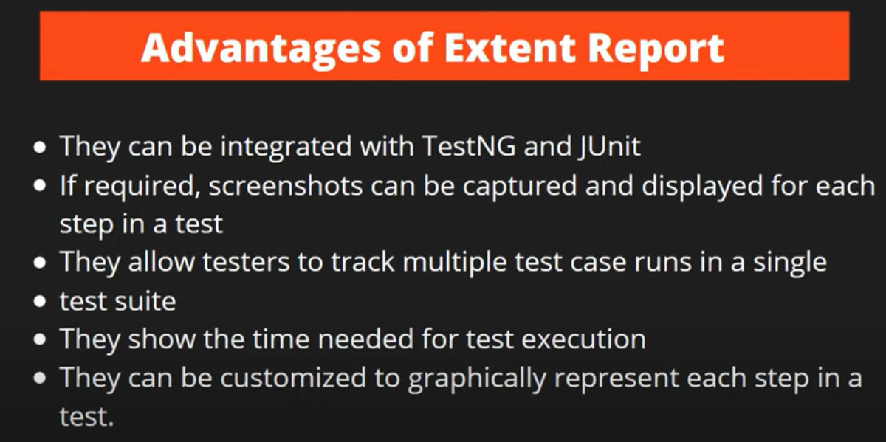

Hooks

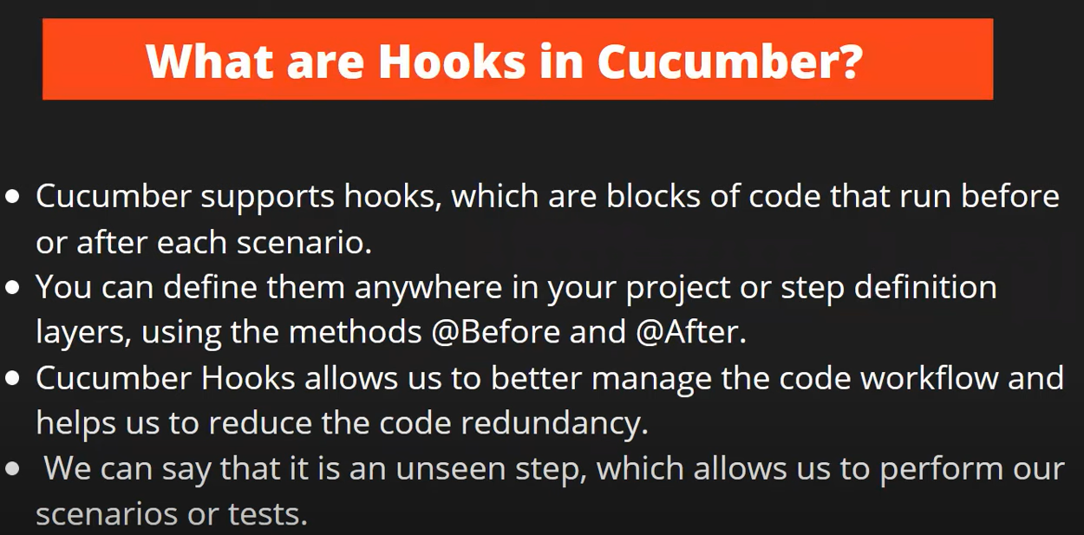

Back Ground

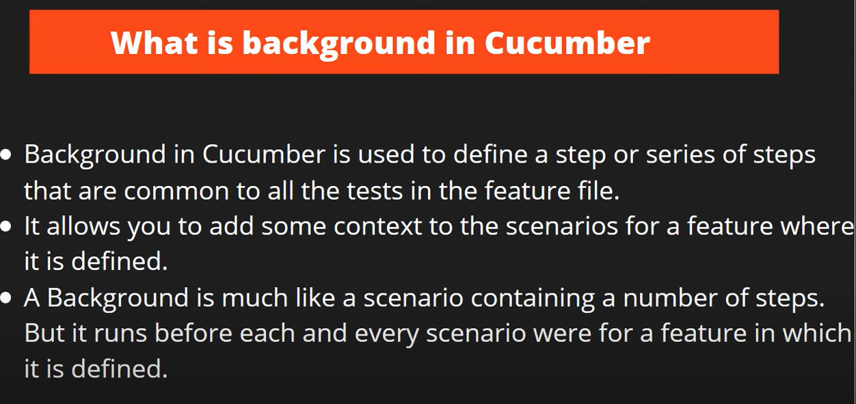

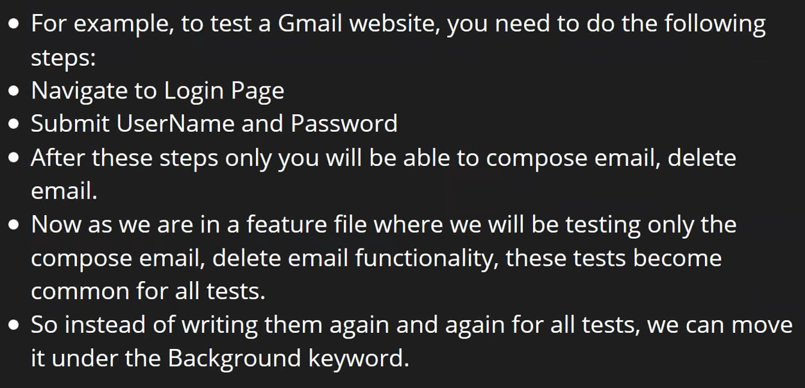

**Hooks and Back ground difference.**

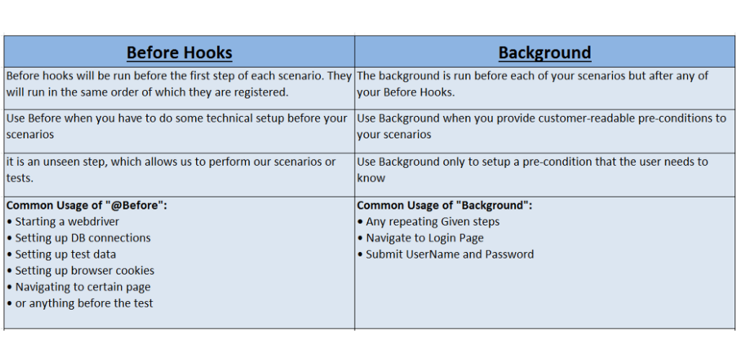

**Exceptions in selenium**

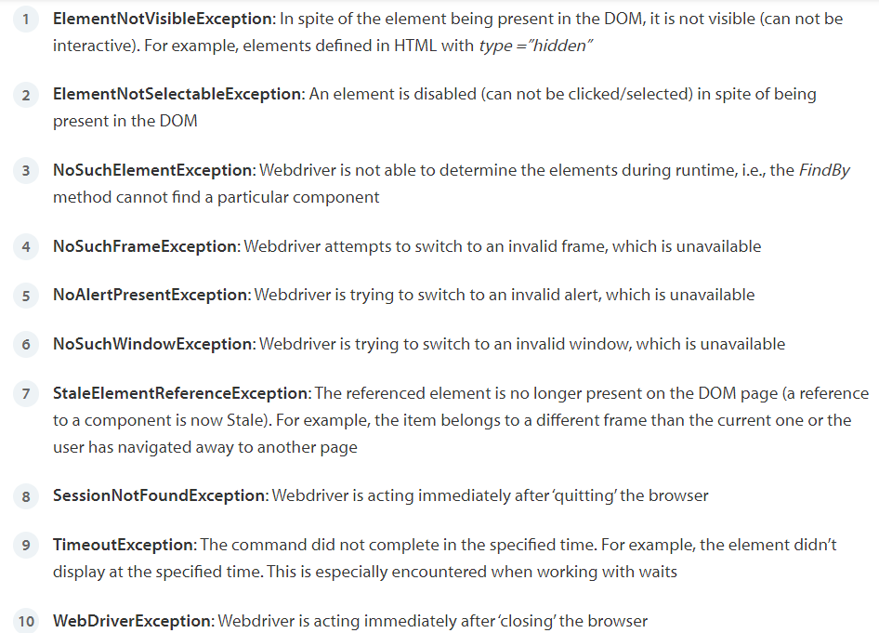

Testng

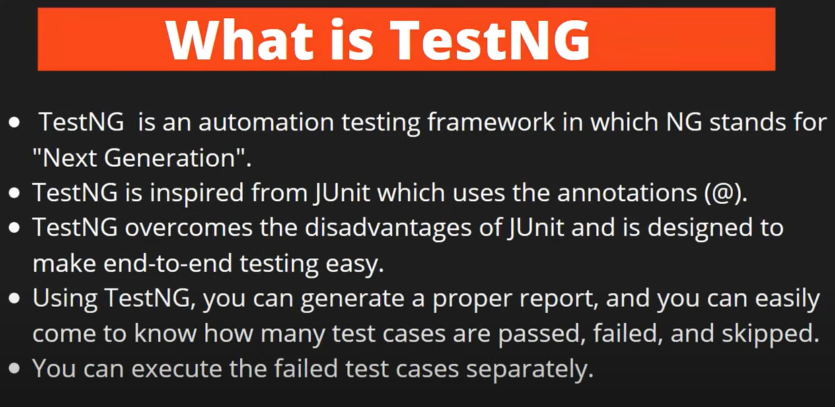

How to read properties file

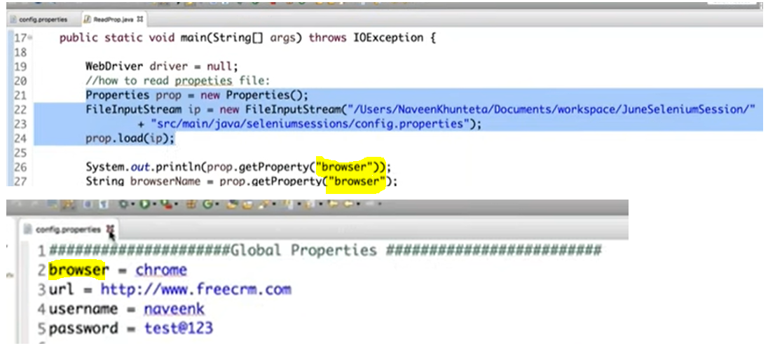

Generate Logs in Selenium - using Log4j API

**Test runner class attributes**

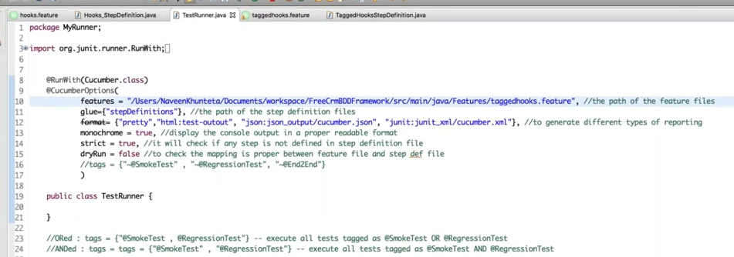

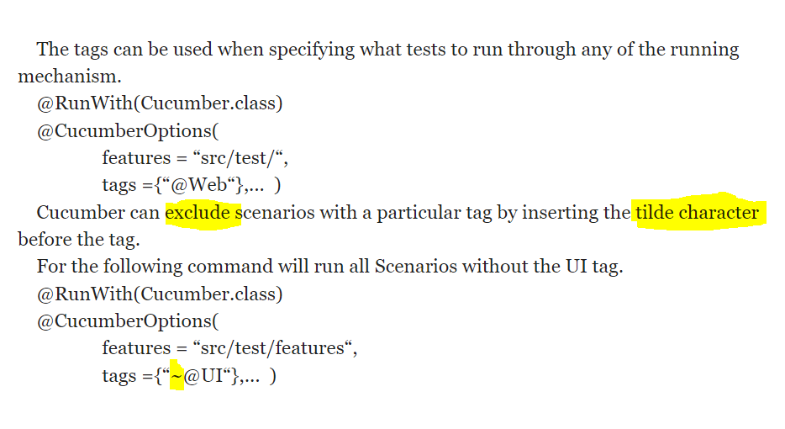

**Steps for Git hub**

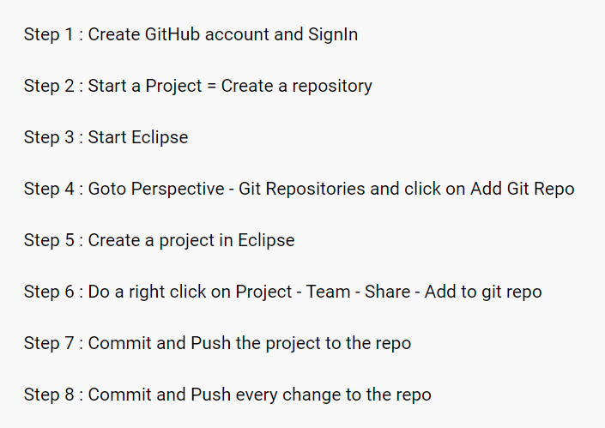

**@beforetest @beforeMethod**

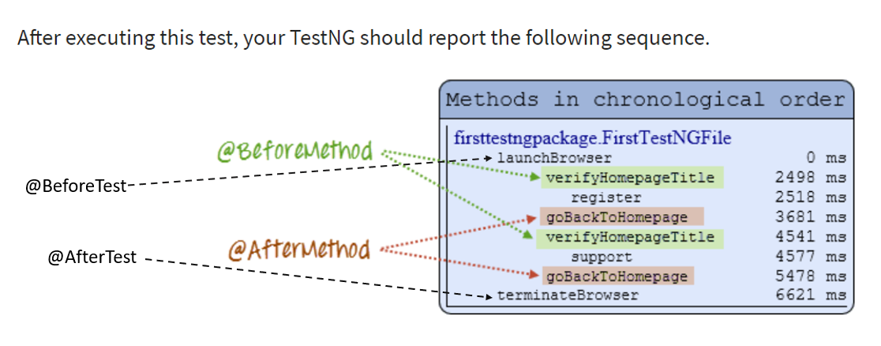

**What happen- using Implicit & Explicit wait together, What happen when we mix Implicit & Explicit wait**

<https://www.youtube.com/watch?v=0rQCiZbsP0w>

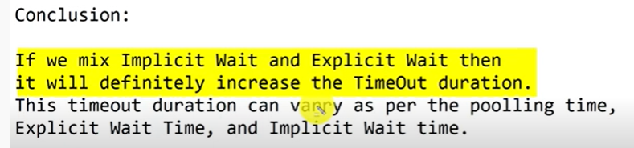

**Hooks**

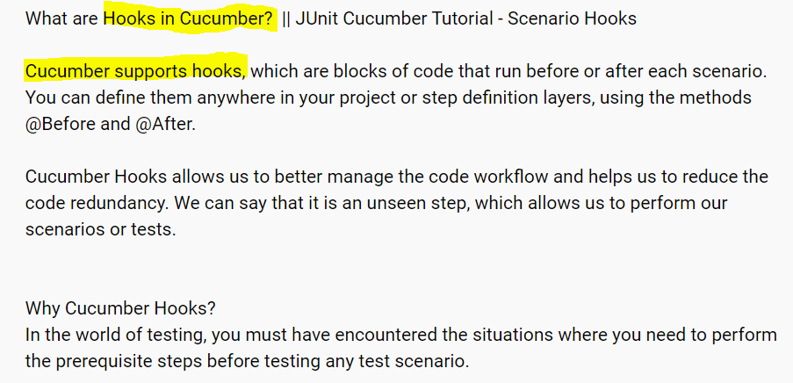

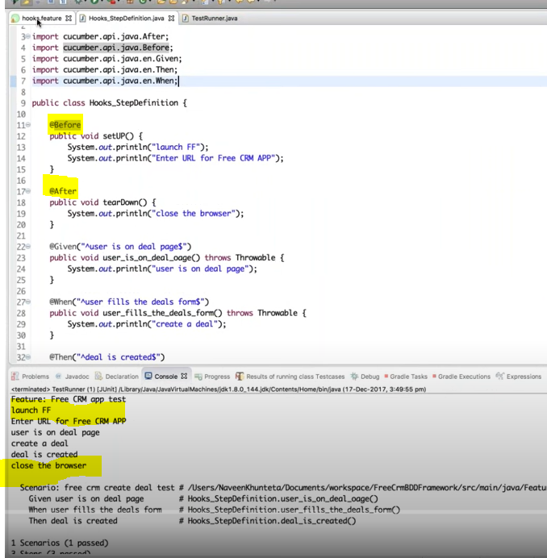

**Tagged Hooks**

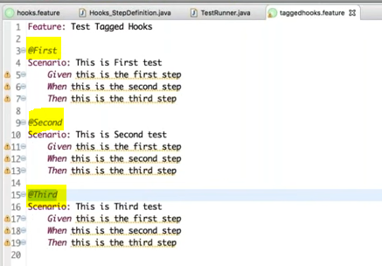

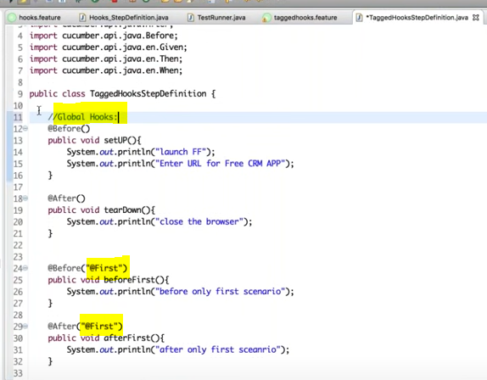

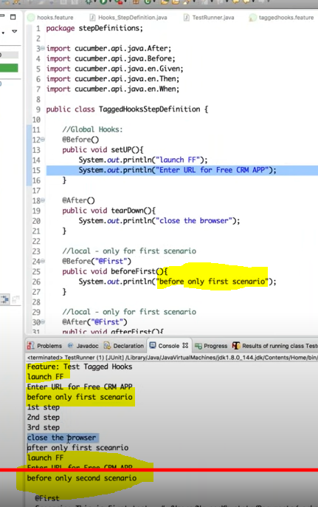

Handing Svg and Shadow-dom elements in UI

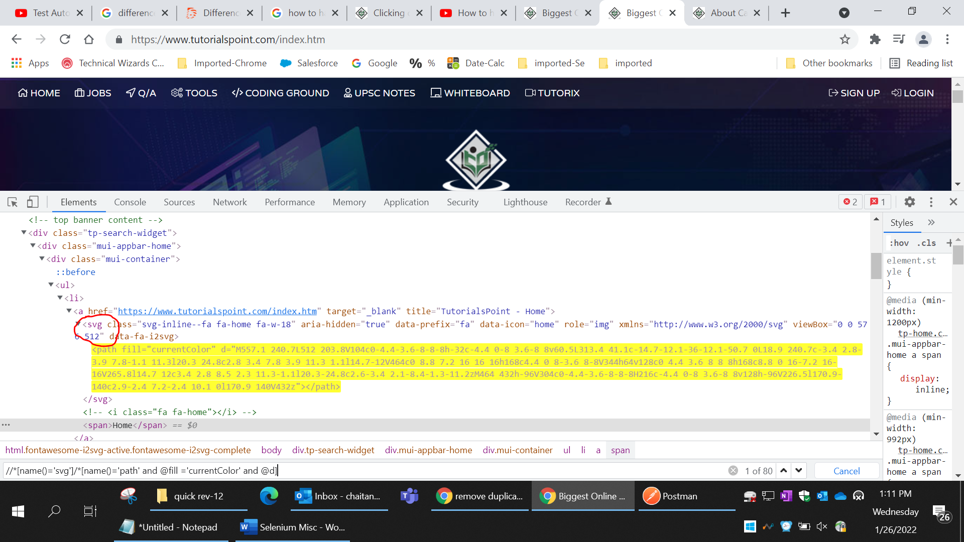

Shadow dom

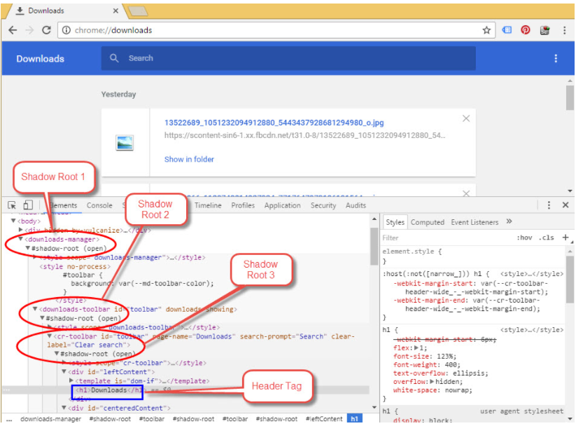

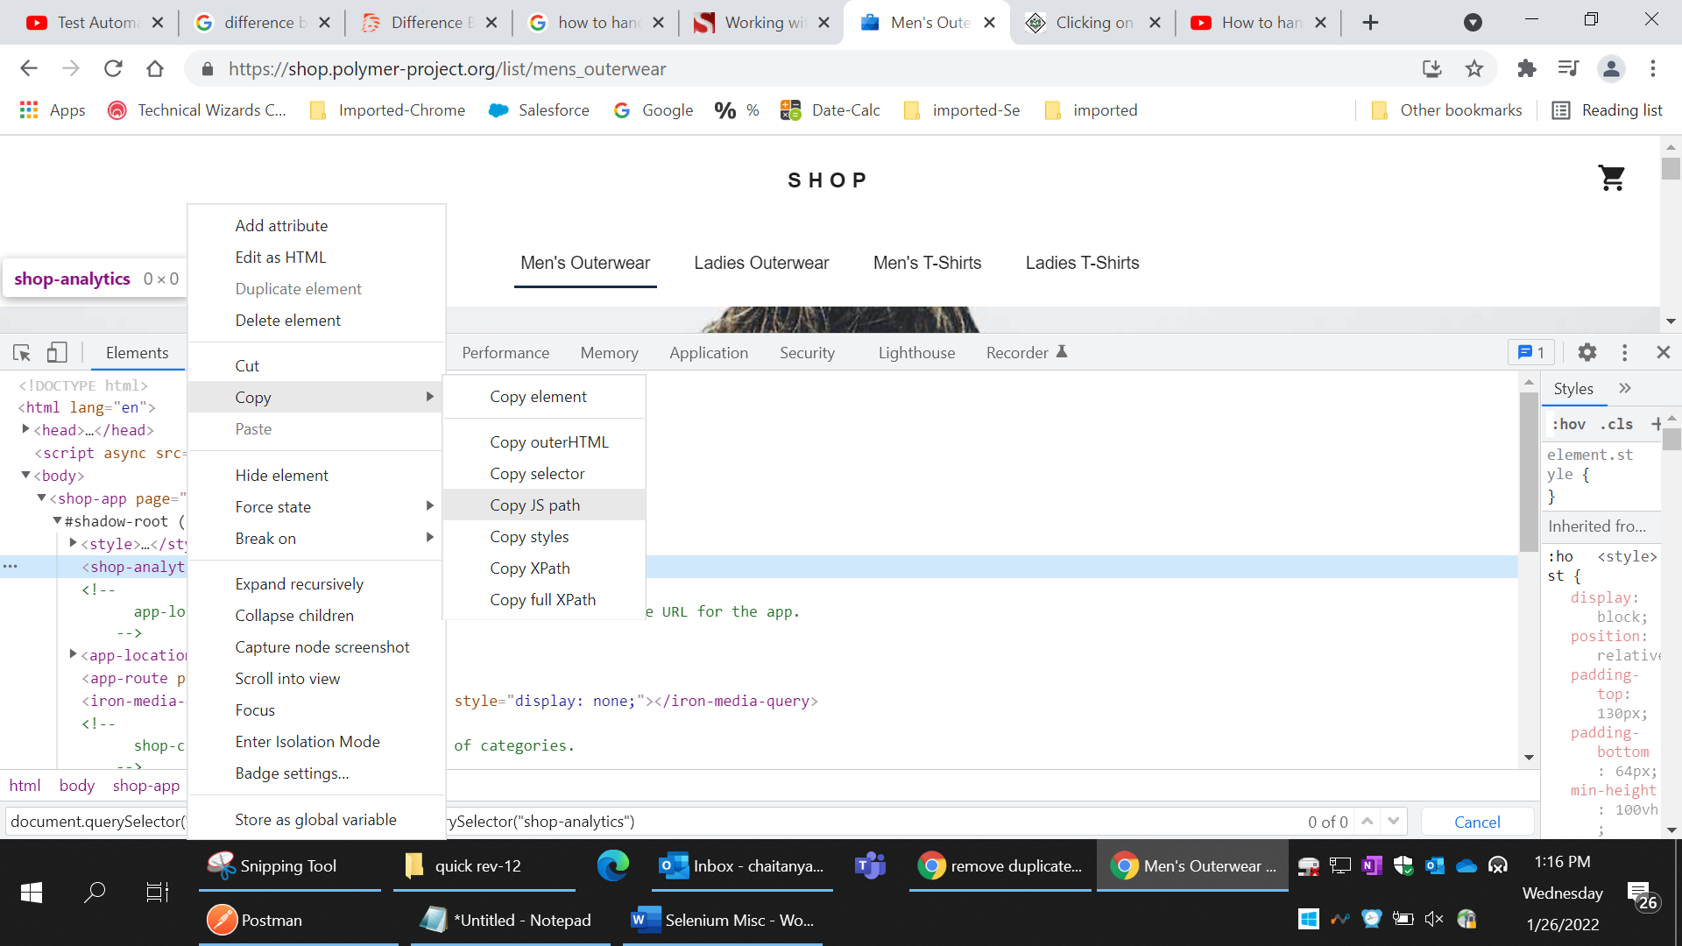

**“Copy JS path”** will help to get xpath to add in javascriptExecutor code or selector

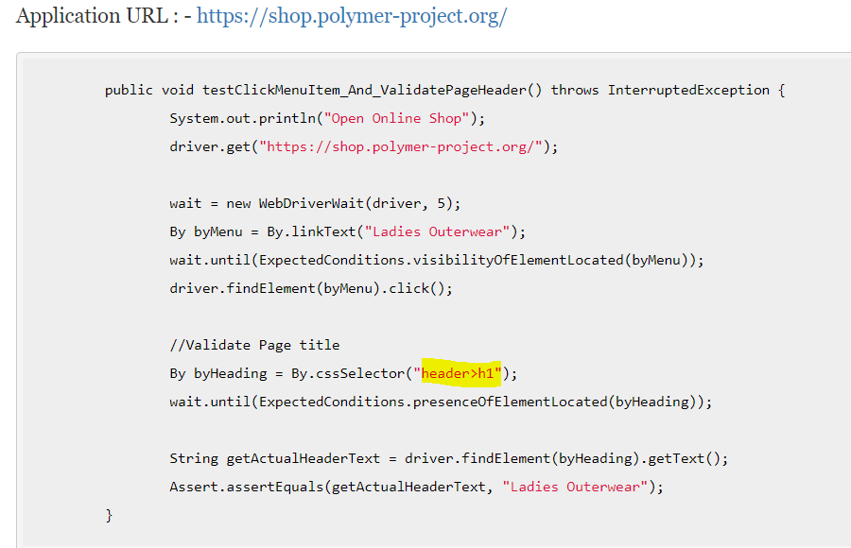

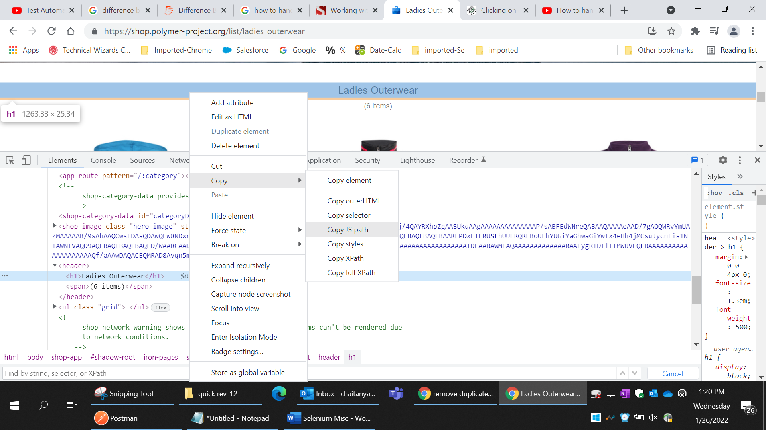

document.querySelector("body > shop-app").shadowRoot.querySelector("iron-pages > shop-list").shadowRoot.querySelector("**header > h1**")

Explain **System.out.println()**

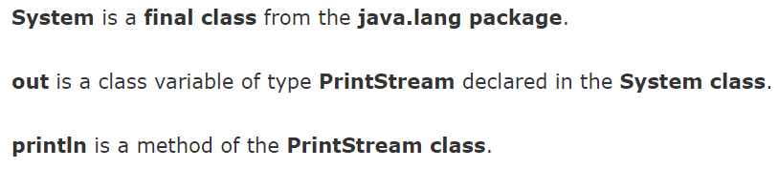

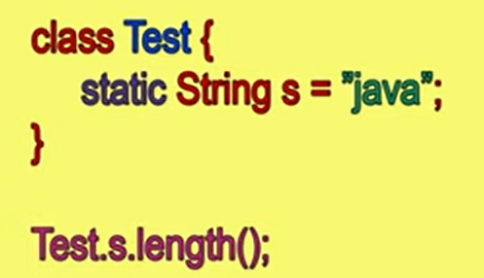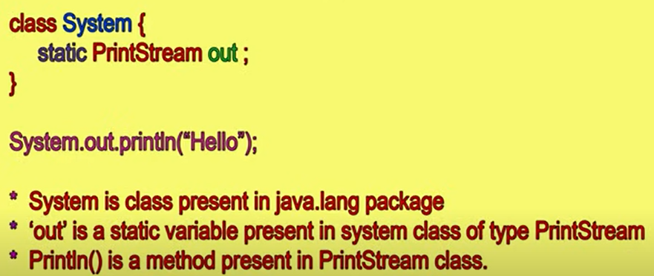

**Webdriver manager**

Webdriver is a selenium library. An interface in selenium to be more specific. Webdriver Manager purpose is to

* ***Handle browser management-****manages our different browser drivers and saves us all the time and effort spent in manually managing the drivers****.***
* **Check for the latest version** of the WebDriver binary, download it if it’s not present on your system and then export the required WebDriver environment variables needed by Selenium.
* WebDriverManager.chromedriver().setup();
* WebDriverManager.firefoxdriver().setup();
* WebDriverManager.operadriver().setup();
* WebDriverManager.phantomjs().setup();
* WebDriverManager.edgedriver().setup();
* WebDriverManager.iedriver().setup();

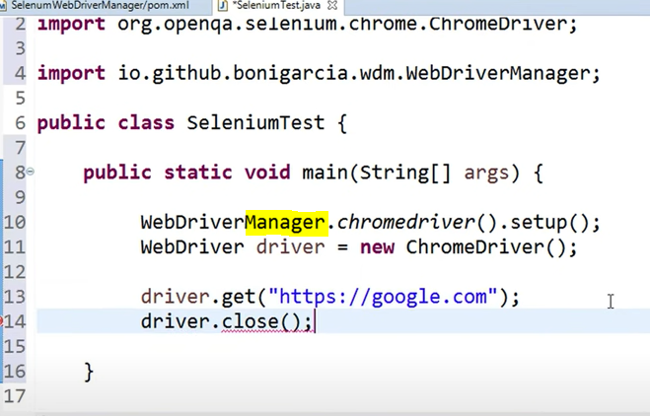

HTTP & HTTP

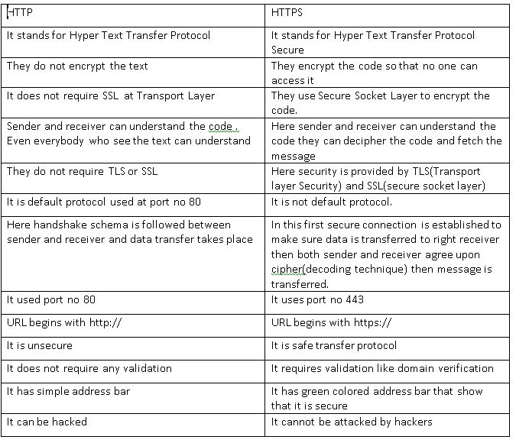

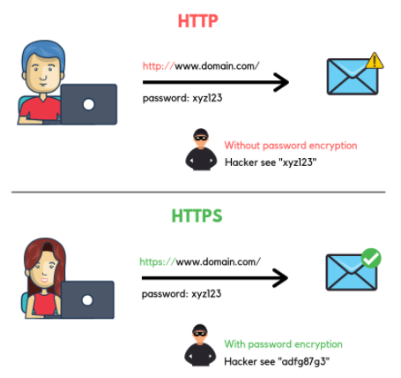

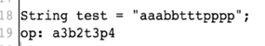 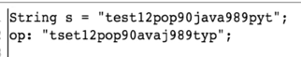

**Selenium 4 Features- Relative locators**

1. above()
2. below()
3. toLeftOf()
4. toRightOf()
5. near()

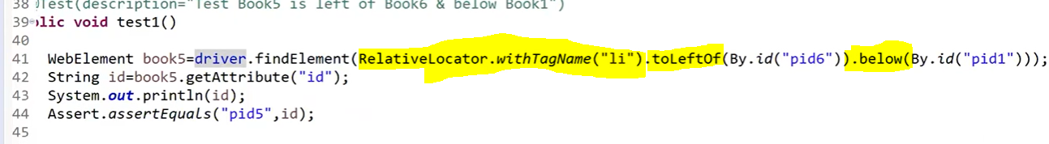

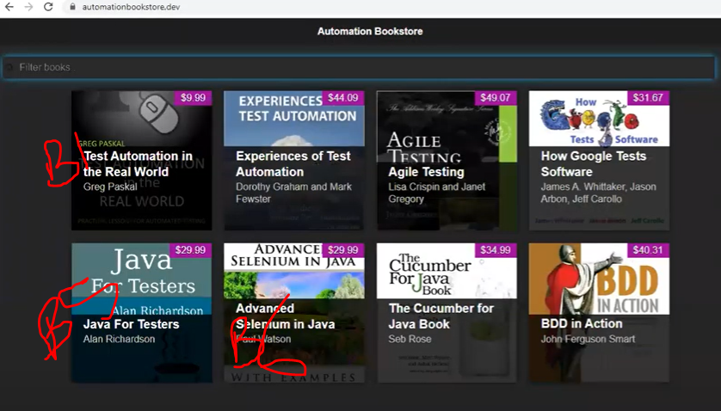

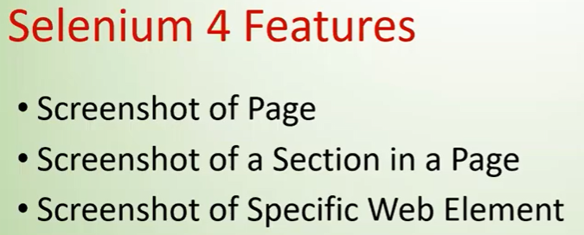

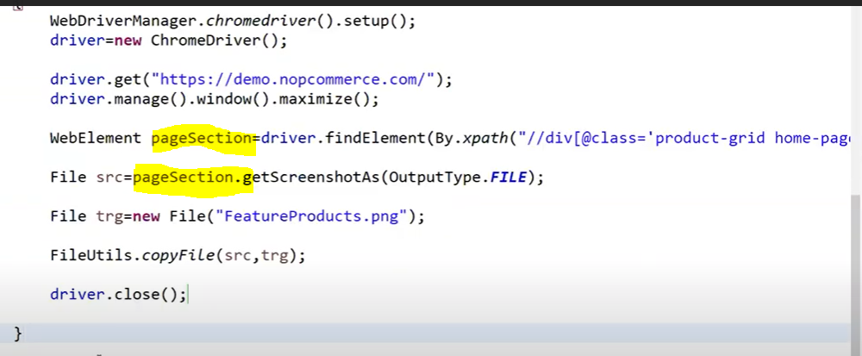

**Assertions**

Asserts are used to perform validations in the test scripts.

There are two types of Assert:

1. Hard Assert
2. Soft Assert

When an assert fails the test script stops execution unless handled in some form. We call general assert as Hard Assert.

**Hard Assert** – Hard Assert throws an Assert Exception immediately when an assert statement fails and test suite continues with next @Test

**Soft Assert** – Soft Assert collects errors during @Test. Soft Assert does not throw an exception when an assert fails and would continue with the next step after the assert statement. If there is any exception and you want to throw it then you need to use assertAll() method as a last statement in the @Test and test suite again continue with next @Test as it is.

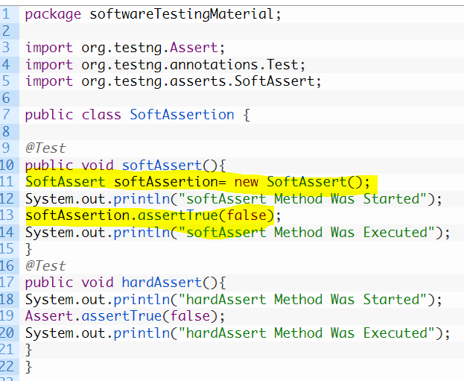 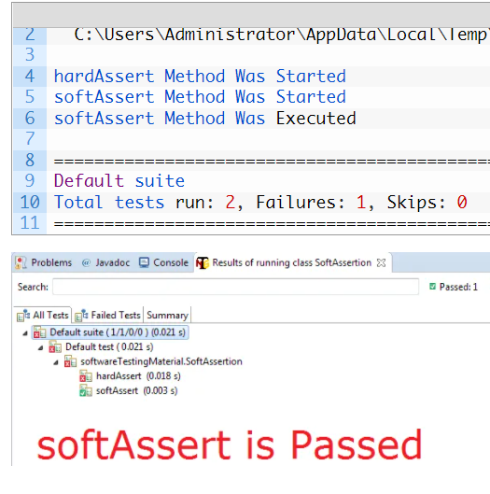

**With AssertAll():**

**Note:** If you forget to call assertAll() at the end of your test, the test will pass even if any assert objects threw exceptions as shown in the above example. So don’t forget to add assertAll()

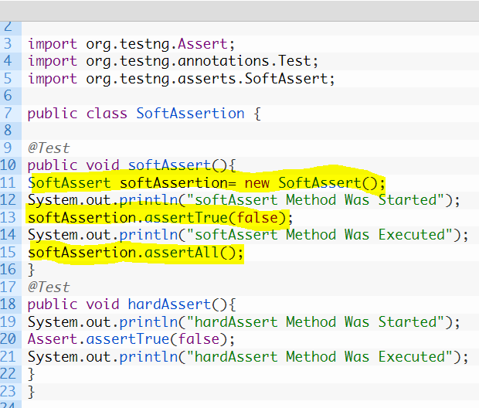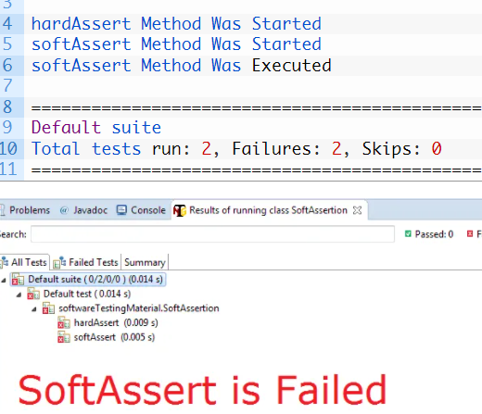

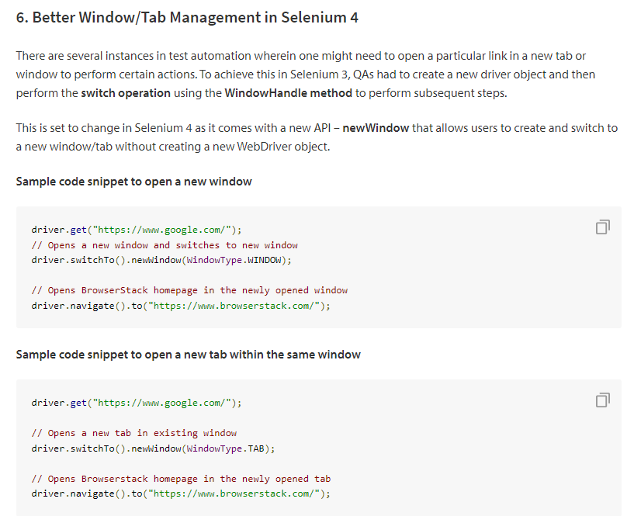

**CI/CD**

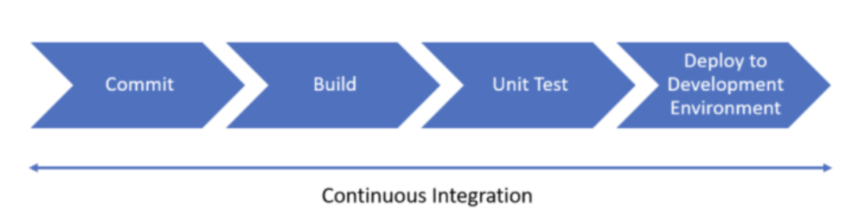

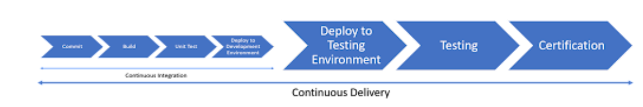

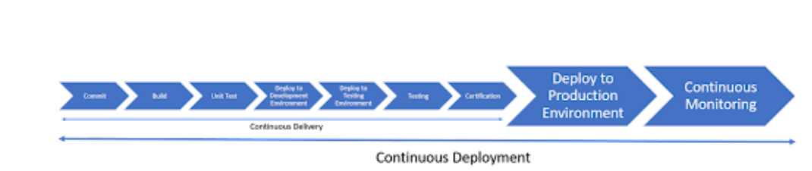

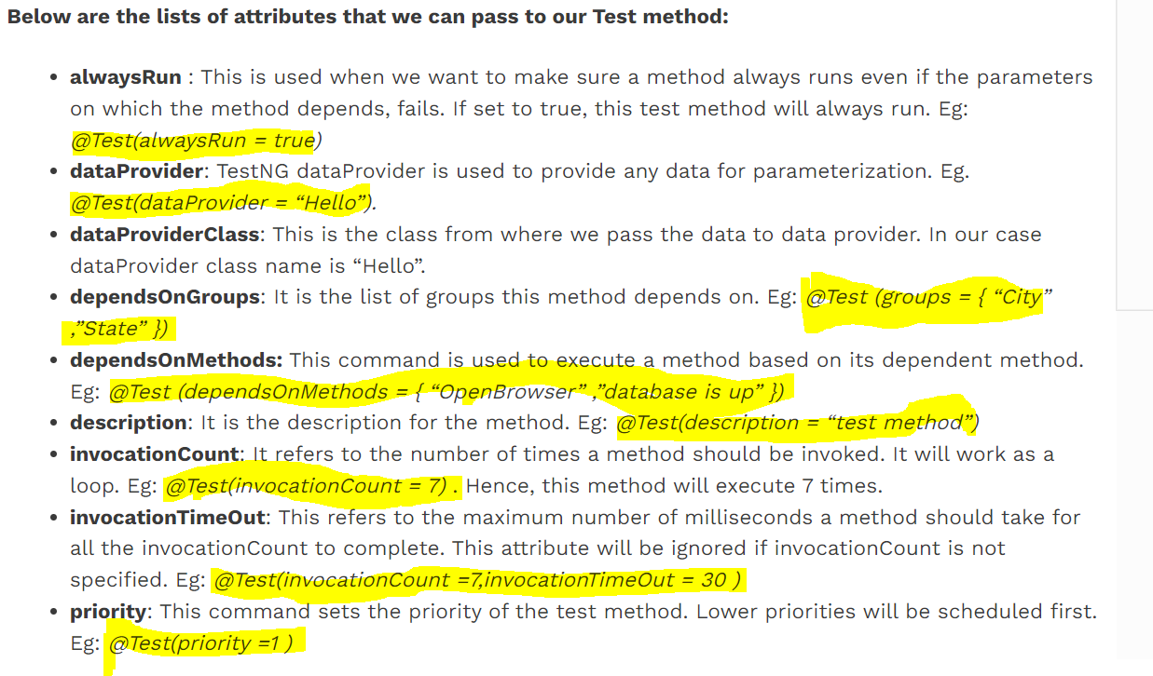

Cookies

